HW7

Qiuying Li UNI ql2280

11/17/2017

library(survival)   
data.cancer<-cancer   
colnames(data.cancer)

## [1] "inst" "time" "status" "age" "sex"   
## [6] "ph.ecog" "ph.karno" "pat.karno" "meal.cal" "wt.loss"

data.cancer$AgeGroup<-ifelse(data.cancer$age < 65, "Young", "Old")   
sfit <- survfit(Surv(time, status)~AgeGroup, data=data.cancer,type="kaplan-meier", conf.type = "log")  
summary(sfit, times = seq(0,1000,100))

## Call: survfit(formula = Surv(time, status) ~ AgeGroup, data = data.cancer,   
## type = "kaplan-meier", conf.type = "log")  
##   
## AgeGroup=Old   
## time n.risk n.event survival std.err lower 95% CI upper 95% CI  
## 0 100 0 1.0000 0.0000 1.00000 1.000  
## 100 80 20 0.8000 0.0400 0.72532 0.882  
## 200 63 12 0.6779 0.0469 0.59189 0.776  
## 300 38 16 0.4888 0.0527 0.39566 0.604  
## 400 25 12 0.3339 0.0516 0.24666 0.452  
## 500 16 8 0.2226 0.0471 0.14708 0.337  
## 600 8 5 0.1457 0.0416 0.08325 0.255  
## 700 5 3 0.0911 0.0360 0.04193 0.198  
## 800 3 2 0.0546 0.0294 0.01902 0.157  
## 900 2 1 0.0364 0.0246 0.00969 0.137  
## 1000 1 0 0.0364 0.0246 0.00969 0.137  
##   
## AgeGroup=Young   
## time n.risk n.event survival std.err lower 95% CI upper 95% CI  
## 0 128 0 1.0000 0.0000 1.0000 1.000  
## 100 116 11 0.9140 0.0248 0.8667 0.964  
## 200 81 29 0.6821 0.0416 0.6052 0.769  
## 300 54 13 0.5636 0.0457 0.4809 0.661  
## 400 32 13 0.4108 0.0493 0.3248 0.520  
## 500 25 4 0.3564 0.0497 0.2711 0.468  
## 600 16 5 0.2765 0.0499 0.1941 0.394  
## 700 11 5 0.1901 0.0470 0.1172 0.309  
## 800 5 5 0.0988 0.0385 0.0460 0.212  
## 900 1 1 0.0494 0.0399 0.0101 0.240  
## 1000 1 0 0.0494 0.0399 0.0101 0.240

library(survminer)

## Loading required package: ggplot2

## Loading required package: ggpubr

## Loading required package: magrittr

ggsurvplot(sfit)

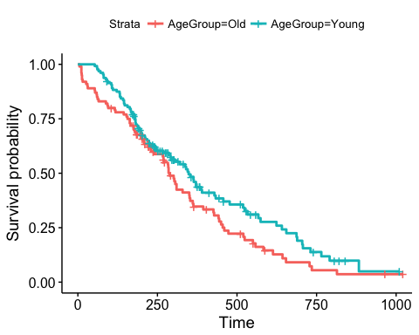

sfit.fh <- survfit(Surv(time, status)~AgeGroup, data=data.cancer,type="fleming-harrington")  
summary(sfit.fh,times = seq(0,1000,100))

## Call: survfit(formula = Surv(time, status) ~ AgeGroup, data = data.cancer,   
## type = "fleming-harrington")  
##   
## AgeGroup=Old   
## time n.risk n.event survival std.err lower 95% CI upper 95% CI  
## 0 100 0 1.0000 0.0000 1.0000 1.000  
## 100 80 20 0.8013 0.0401 0.7265 0.884  
## 200 63 12 0.6799 0.0471 0.5937 0.779  
## 300 38 16 0.4923 0.0531 0.3985 0.608  
## 400 25 12 0.3387 0.0523 0.2502 0.458  
## 500 16 8 0.2281 0.0482 0.1507 0.345  
## 600 8 5 0.1520 0.0434 0.0868 0.266  
## 700 5 3 0.0984 0.0389 0.0453 0.214  
## 800 3 2 0.0628 0.0338 0.0218 0.180  
## 900 2 1 0.0450 0.0304 0.0120 0.169  
## 1000 1 0 0.0450 0.0304 0.0120 0.169  
##   
## AgeGroup=Young   
## time n.risk n.event survival std.err lower 95% CI upper 95% CI  
## 0 128 0 1.0000 0.0000 1.0000 1.000  
## 100 116 11 0.9144 0.0248 0.8671 0.964  
## 200 81 29 0.6836 0.0417 0.6066 0.770  
## 300 54 13 0.5657 0.0458 0.4827 0.663  
## 400 32 13 0.4143 0.0497 0.3275 0.524  
## 500 25 4 0.3602 0.0503 0.2740 0.474  
## 600 16 5 0.2813 0.0508 0.1975 0.401  
## 700 11 5 0.1961 0.0484 0.1209 0.318  
## 800 5 5 0.1064 0.0415 0.0495 0.229  
## 900 1 1 0.0645 0.0521 0.0133 0.314  
## 1000 1 0 0.0645 0.0521 0.0133 0.314

ggsurvplot(sfit.fh)

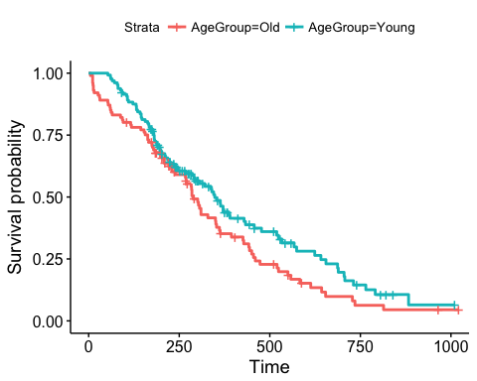 2.For each case in 1, estimate the median survival time, using the estimated survival curves

print(sfit,print.rmean = T)

## Call: survfit(formula = Surv(time, status) ~ AgeGroup, data = data.cancer,   
## type = "kaplan-meier", conf.type = "log")  
##   
## n events *rmean *se(rmean) median 0.95LCL 0.95UCL  
## AgeGroup=Old 100 79 332 26.5 288 239 353  
## AgeGroup=Young 128 86 412 27.8 348 291 433  
## * restricted mean with upper limit = 1016

print(sfit.fh,print.rmean = T)

## Call: survfit(formula = Surv(time, status) ~ AgeGroup, data = data.cancer,   
## type = "fleming-harrington")  
##   
## n events *rmean *se(rmean) median 0.95LCL 0.95UCL  
## AgeGroup=Old 100 79 337 27.9 288 239 353  
## AgeGroup=Young 128 86 418 29.1 348 291 433  
## * restricted mean with upper limit = 1016

3.Using a log-rank test, compare the survival distributions for Male and Female

survdiff(Surv(time, status)~sex,data = data.cancer,rho = 0)

## Call:  
## survdiff(formula = Surv(time, status) ~ sex, data = data.cancer,   
## rho = 0)  
##   
## N Observed Expected (O-E)^2/E (O-E)^2/V  
## sex=1 138 112 91.6 4.55 10.3  
## sex=2 90 53 73.4 5.68 10.3  
##   
## Chisq= 10.3 on 1 degrees of freedom, p= 0.00131